
ID TECH uSign 100 & 200 __________
Selling Sheet
Overview

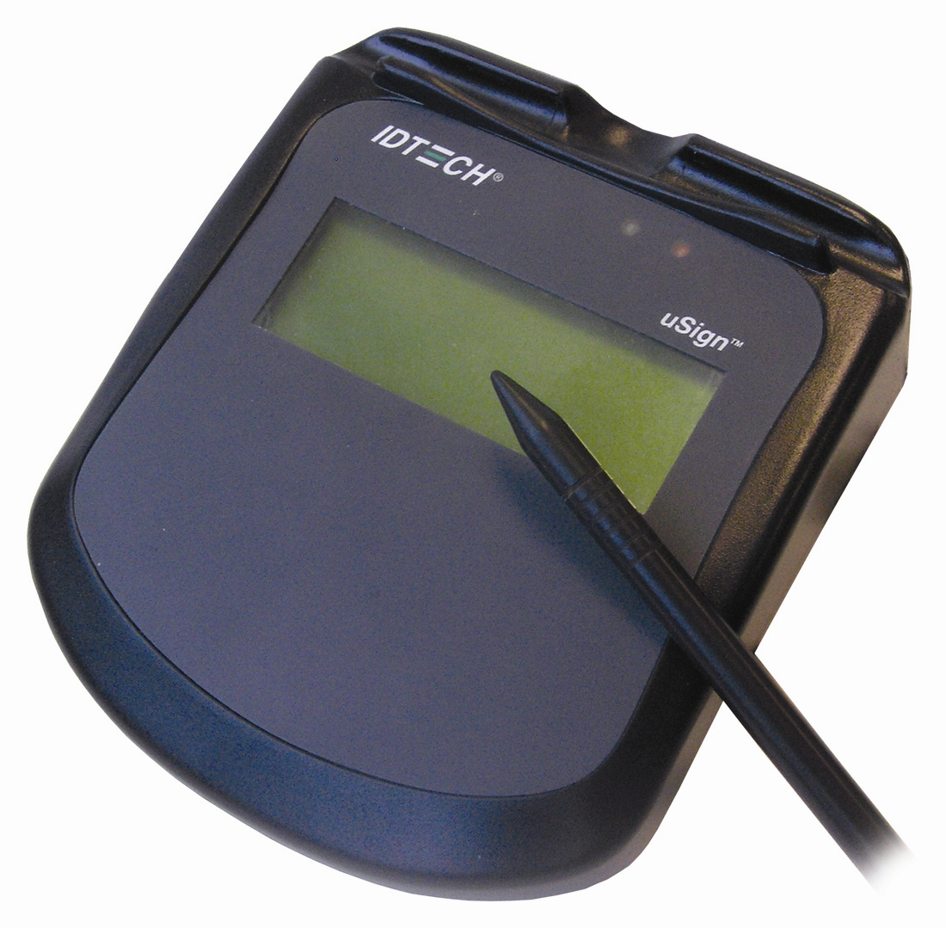
On behalf of ID TECH, we are pleased to introduce our uSign 100 & 200, signature capture pads. It is the ultimate solution to your POS applications, which includes hospitality, self-service and quick service restaurants…etc.

The uSign is an electronic signature capture device with a back-lighted graphic LCD signature panel. There are 2 models – OEM ( uSign 100 ) and counter top ( uSign 200 ) versions. The front housing and signature panel overlay is removable for replacement when the signature panel is worn. The overlay can be customized to allow customers to put their own logos. There are 2 different interfaces available – RS232 (request power supply ) and USB/CDC ( no power supply request ).

Features
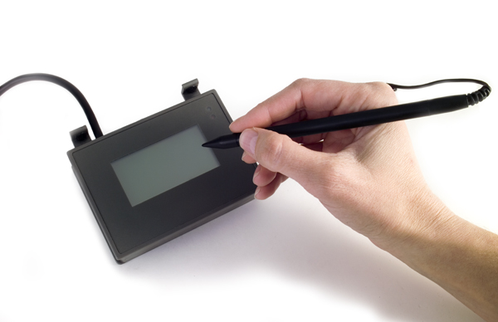
- Replaceable tethered stylus
- Resistive touch pad with transparent, replaceable protective overlay
- Electronic signature capture with buffered signature capability
- Sampling rate up to 190 dots per second 1024 dot/inch resolution
- Real time signature capture with 5:1 compression
- Raw data output available
- Firmware filters spikes and provides smoothing
- Graphics real-time display of signature during capture
- Host controlled graphics display when not in signature process
- Calibration mode or function
- Command & response driven operations through an API
- Demo application runs in Windows 2000, XP and Visa environment

Target Market

The uSign 100 & 200 has its target market terminal manufacturers and system integrators. In addition, we are introducing this product to the market through our channel partners. It is positioned to compete with Topaz and replacement of HandHeld Product TT1500 with a compact size and better price point. We offer the OEM version – uSign100 ( no ID TECH logo ) and finished product version – uSign 200 ( with ID TECH logo ). Private labeling is available with MOQ 1000 pcs.

Part Number

 | TYPE | TECH | INTERFACE | HOUSING | TRACK | CUSTOM
IDUA- | 0 = Signature Capture | 1 = Signature Pad only | 2 =RS232 | 1=PW-120 housing OEM | 00 = No Magnetics | - ZZ
 |  | 2= Signature Pad w/MSR | 6 = USB-CDC | 5=standard

** For Example: IDUA-016500: uSign 200, USB-CDC interface

List Pricing

Model # | Description | List Price
IDUA-012500 | uSign 200, RS232 interface, include power supply | $428.00
IDUA-016500 | uSign 200, USB-CDC interface | $448.00

Lead time

The standard lead time of products on quick ship list is 1-2 weeks for orders under 100 units and 10-12 weeks for orders over 500 units.

Comparison

Manufacture | ID TECH | Topaz | HHP
Model | uSign 200 | Topaz T-L755 | TT1500
Interfaces | USB/CDC and RS232 | USB and RS232 | RS232
LCD size | 3.13 x 1.14” | 4.2 x 2.5” | 2.48 x 1.26”
LCD Color | Monochrome (green & black | Monochrome (white & blue) | Monochrome (green & black)
LED | Green and Red | N/A | Green & Red
LCD Backlit | Yes | Yes | Yes
Resolution | 192 x 64 | 240 x 128 | 418x798
Unit Dimension | 5.4” x 7.7” x 1.4” | 7.8” x 6.3” x 1.6” | 7.9” x 6.0” x 1.5”
Weight | 0.82lb (0.37kg) | N/A | 16 oz (0.45kg)
Compression | 5:1 | N/A | 5:1
Warranty | 1 year | 3 year with renewal option | 1 year
Agency Approval | FCC & CE Class B ( uSign 100 with UL ) | N/A | FCC & CE Class A, UL

Applications

- POS Systems
- Hospitality
- Self-service
- Retails

Warranty

ID TECH warrants to the original purchaser of uSign for a period of 12 months (1 year) from date of invoice.

